Irish Life Health dac

Written COR data transfer process for automation

Documented by Darragh Lynch for Anthony Slator

Date: June 2021

Step 1:

In the **Musketeer Written COR YYYYMM Granular Version** spreadsheet, add a new tab named ‘PIVOT_TO_COPY’ which takes values from the ‘Pivot’ tab and rounds numerical values to 2 decimal places.

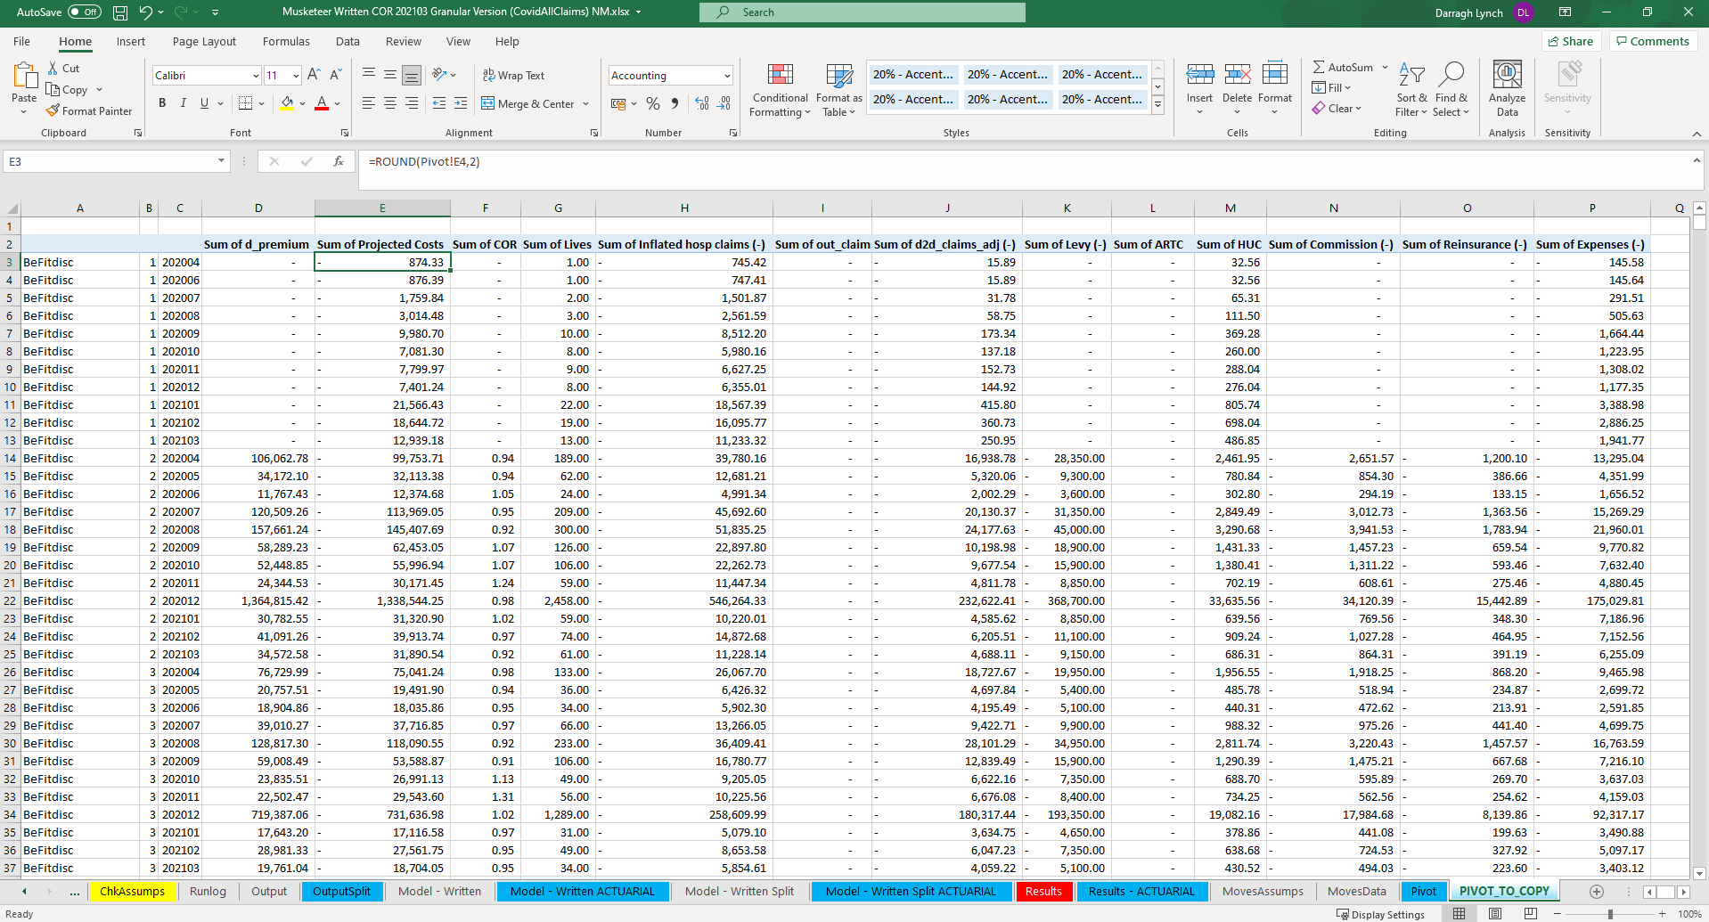

Step 2:

We are only concerned with pasting values from row 3 onwards in the ‘PIVOT_TO_COPY’ tab.

Copy the values from columns A-P in the ‘PIVOT_TO_COPY’ tab and paste them into columns B-Q of the ‘Written CORs’ tab of the **Mass Lapse – Month Year** spreadsheet, underneath the headings in row 1.

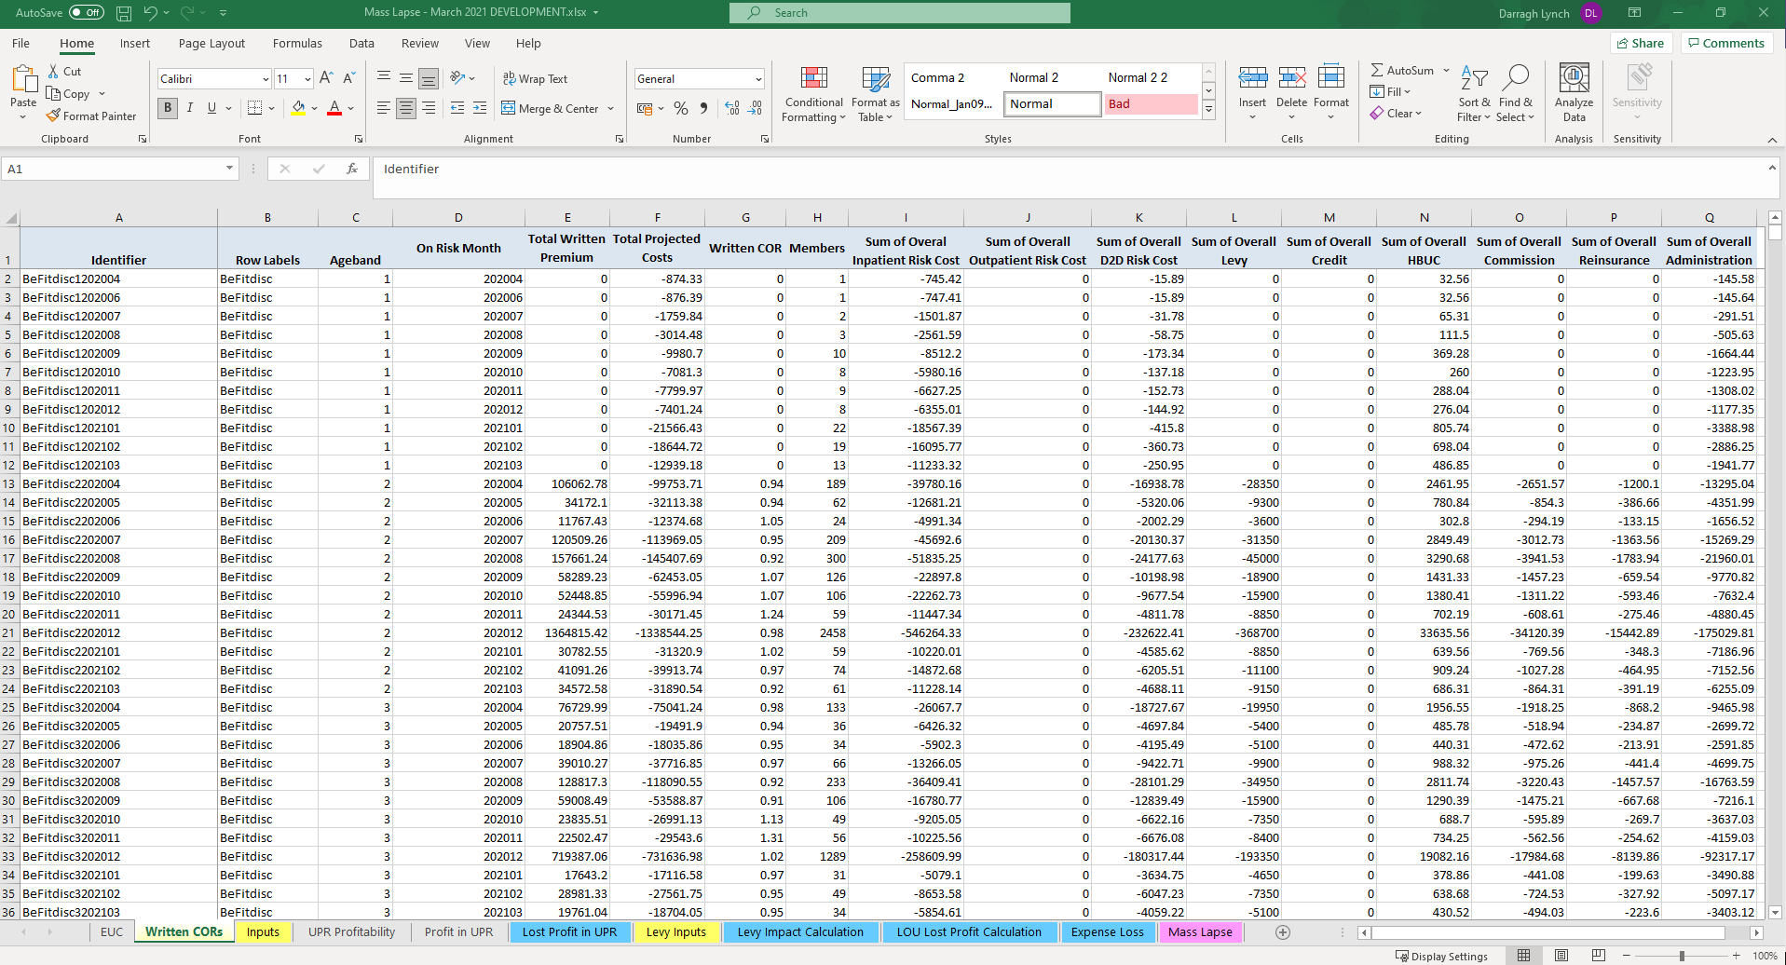

Step 3:

Ensure the formula in column A of the ‘Written CORs’ tab of the **Mass Lapse – Month Year** spreadsheet is copied down for all rows which contain data in columns B-Q.

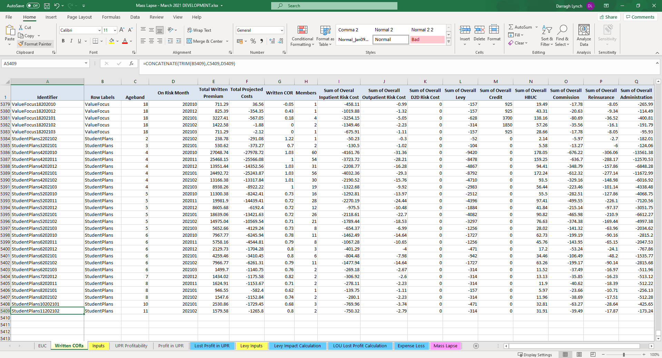

Step 4:

Save both spreadsheets.